Lab 3
Vaibhav Sandhir
210905152

Q1.)
import numpy as np

A = np.array ([2,5,10])
print(A.dtype)
B=np.array ([2.4,10.6,5.2])
print(B.dtype)
A=np.array([(3,4,5),(12,6,1)])
print(A)
Z=np.zeros((2,4))
print(Z)
S=np.arange(10,30,5)
print(S)
S1=np.linspace(0,2,9)
print(S1)

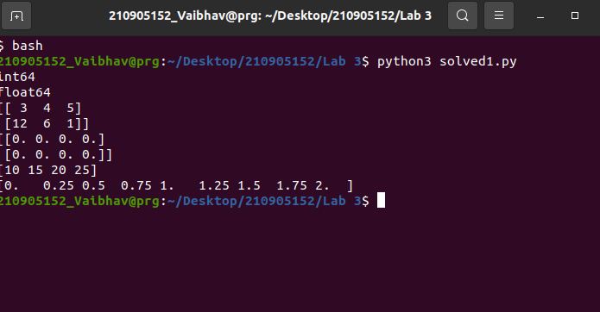
Q2.)

import random
print(random.choice([1,2,3,4,5]))
print(random.choice('python'))
print(random.randrange(25,50))
print(random.randrange(25,50,2))
print(random.random())
print(random.uniform(5,10))
print(random.shuffle([1,2,3,4,5]))
print(random.seed(10))

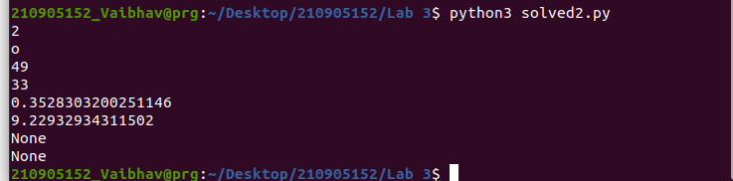
Q3.)

import numpy as np

a = np.arange(15).reshape(3, 5)
print(a)
print(a.shape)
print(a.size)
print(a.T)
c = np.arange(24).reshape(2,3,4)
print(c)
print(c.shape)
A = np.array( [[1,1],[0,1]] )
B = np.array( [[2,0],[3,4]] )
print(A*B)
print(A.dot(B))
b = np.arange(12).reshape(3,4)
print(b)
print(b.sum(axis=0))
print(b.sum(axis=1))

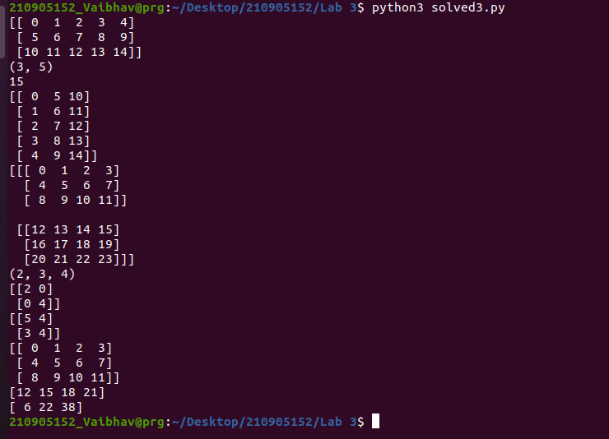
Q.4)
import numpy as np

a = np.arange(10)**3
print(a)
print(a[2:5])
print(a[0:6:2])
b = np.array([[ 0, 1, 2, 3],
[10, 11, 12, 13],
[20, 21, 22, 23],
[30, 31, 32, 33],
[40, 41, 42, 43]])
print(b[2,3])
print(b[-1,:])
print(b[:,-1])
for row in b:
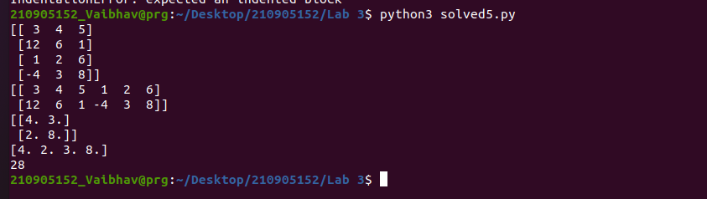
print(b)

Q.5)
import numpy as np

A1=np.array([(3,4,5),(12,6,1)])
A2=np.array([(1,2,6),(-4,3,8)])
D1=np.vstack((A1,A2))
D2=np.hstack((A1,A2))
print(D1)
print(D2)
a = np.array([4.,2.])
b = np.array([3.,8.])
print(np.column_stack((a,b)))
print(np.hstack((a,b)))
a=np.array([(3,2,9),(1,6,7)])
s=0
for i in range(a.shape[0]):
for j in range(a.shape[1]):
s+=a[i,j]
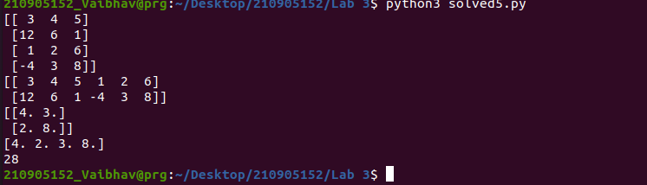
print(s)

